DVI with USB CAT5 Extender
ITEM NO.: DE01U
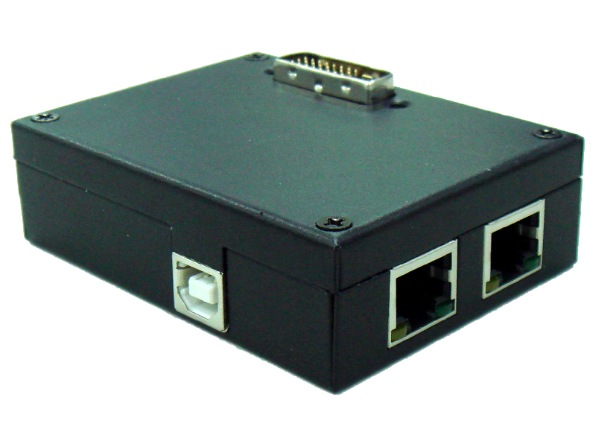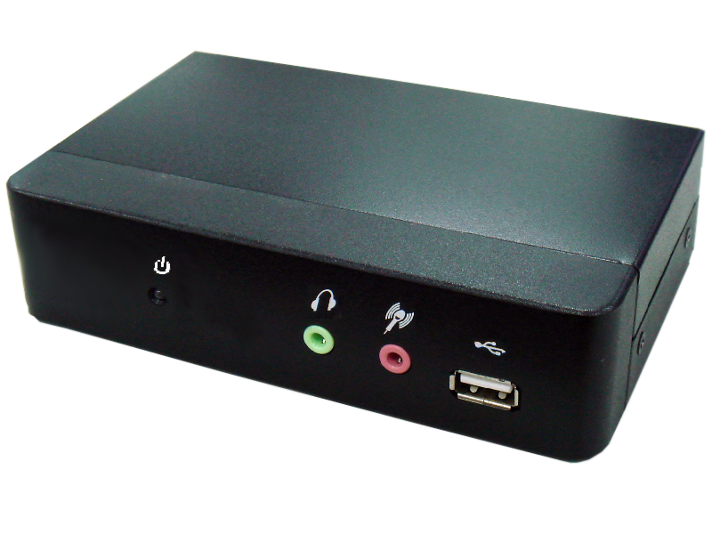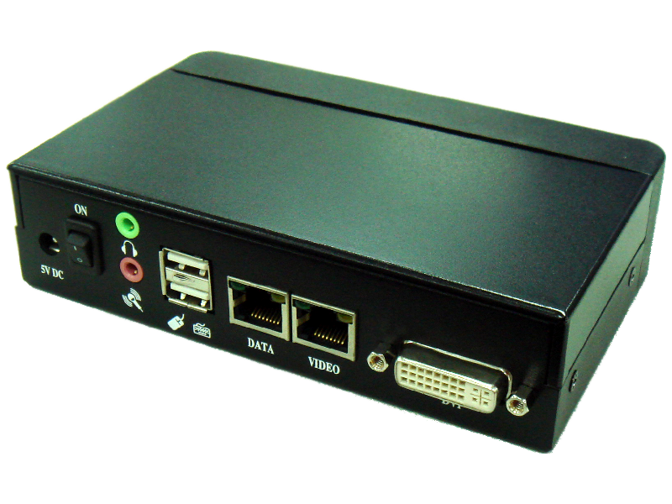
The DVI with USB CAT5 Extender allows DVI video and USB signals be transmitted up to 45 meters via two CAT5 UTP cable. Used in pairs, the Extender is used in home or commercial applications as a smart, fast and cost-effective, eliminates costly and bulky DVI, USB cable.
Applications for classroom projector systems, boardroom systems, collaborative PC systems C-training systems, and tradeshows PC demo systems and medical information systems.

DVI with USB 1.1 CAT5 Extender over two CAT5
- Include DE01UT transmitter, DE01UR receiver, used in pairs via two CAT5E/6 cable to send DVI and USB signal.
- Built in 3 port USB Hub & USB Audio.
- Support high resolution up to 1920 x 1200.
- Transmission distance up to 45 meters at 1920 x 1080.

Installation View:
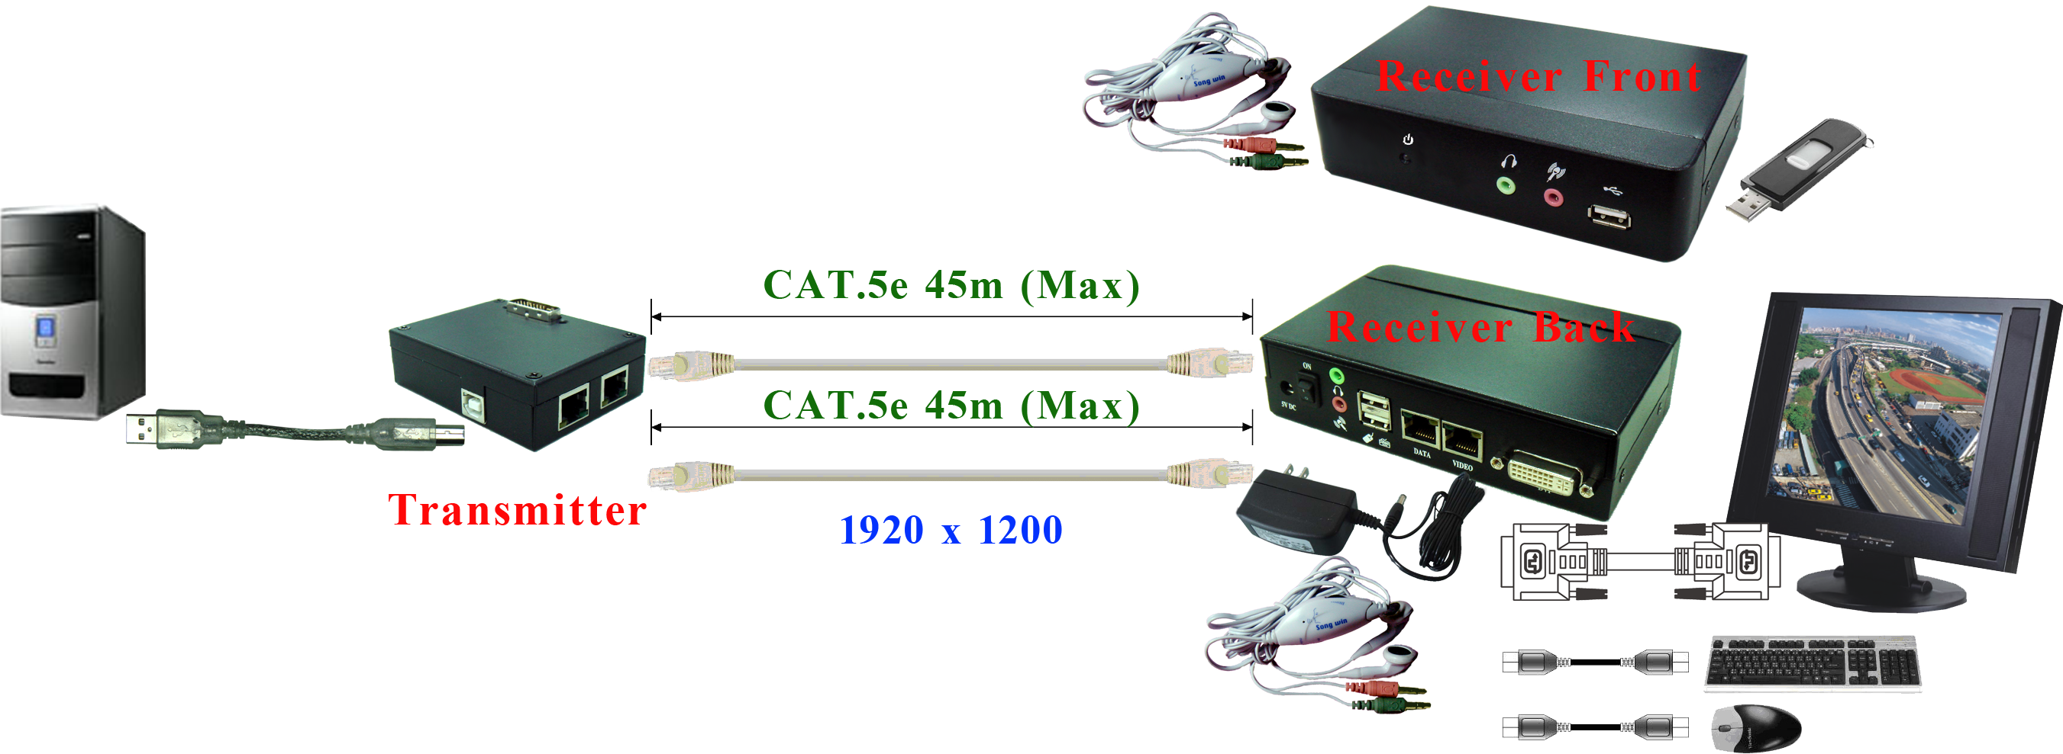
Panel View:

DE01UT (Remote unit)

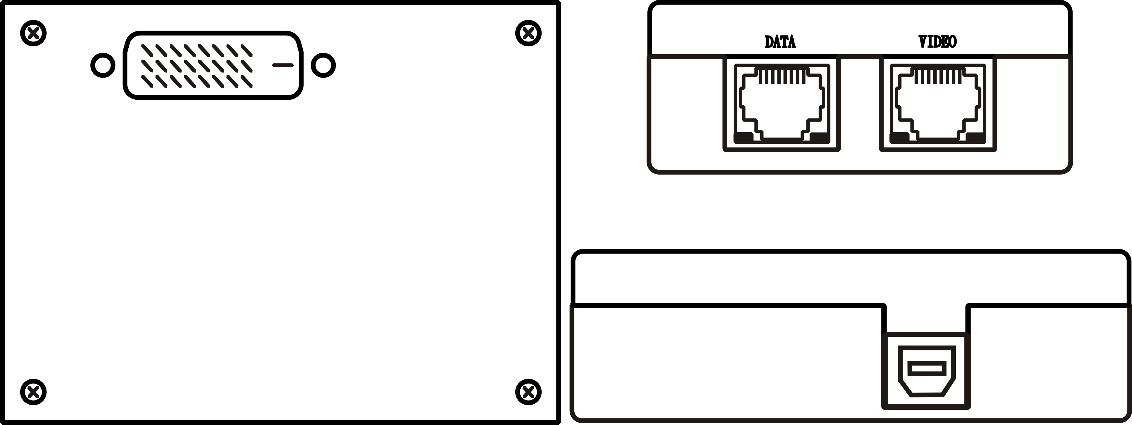
DE01UR (Local unit)

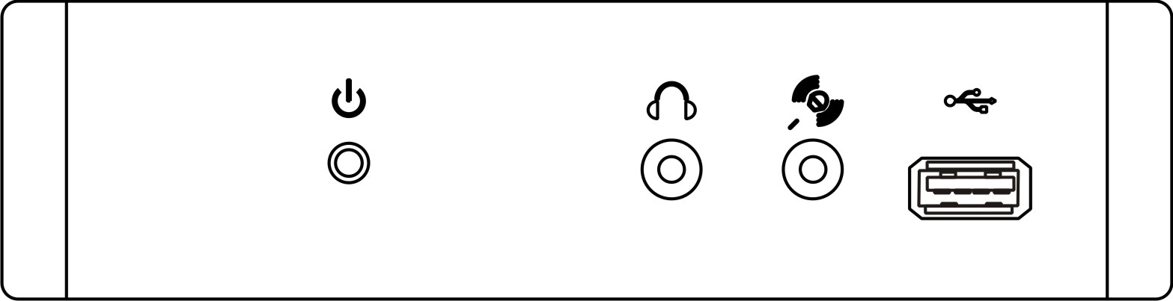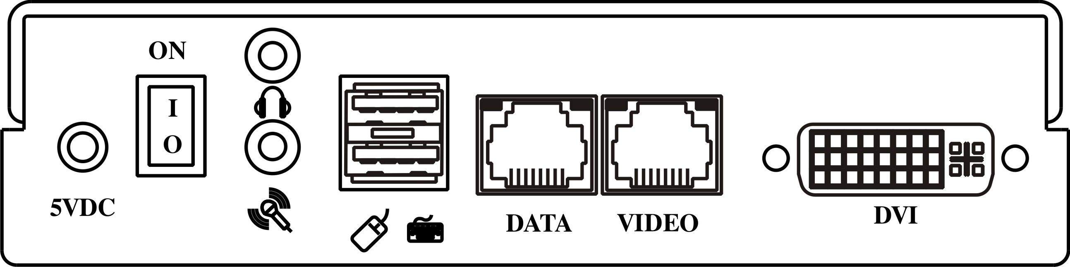
Recommend Cable:
Video Link Cable use high quality Cat.5e / Cat.6 UTP cable.
Data Link Cable use high quality Cat5/5e UTP cable.

Transmission Distance:
The transmission distance will be affected from different DVI equipment and cable quality.
Using Cat.5e cable up to 45M.at 1920 x 1200 resolution.

RJ45 Pin Configuration: TIA/EIA 568B Wiring standard
Video Link
1. Orange-white TMDS DATA2 +
2. Orange TMDS DATA2 -
3. Green-white TMDS CLOCK +
4. Blue TMDS DATA1 +
5. Blue-white TMDS DATA1 -
6. Green TMDS CLOCK -
7. Brown-white TMDS DATA0 +
8. Brown TMDS DATA0 -

Data Link
1. Orange-white USB+
2. Orange GND
3. Green-white USB-
4. Blue GND
5. Blue-white RESERVE
6. Green GND
7. Brown-white RESERVE
8. Brown GND

Button, Switch Instruciton:
DE01UR Back Panel：
POWER SW DE01UR Power on/off

LED Indication:
DE01UT RJ-45：
VIDEO LINK
GREEN DVI Power on
YELLOW Not Detect MONITOR HPD signal

DATA LINK
GREEN PC USB Power on

DE01UR Front Panel：
PWR / LINK Power , Link on/off
BLUE PC Power on
RED PC Power off, unlink
OFF DE01UR Power off

DE01UR Back Panel：
VIDEO LINK
GREEN DVI Power on signal
YELLOW Net Detect DVI Video Signal

DATA LINK
GREEN USB Status Normal

Caution:

- The wiring must be away from electro magnetic equipment, i.e. microwave, wireless, high voltage cable…etc., to avoid any interference.

- All wiring is “straight-through” twisted pair cable, not being used for other LAN or telephone equipment.

Specification:

ITEM NO. | DE01U
Resolution | Up to 1920 x 1200 @60Hz
Link Cable Distance | 45 Meters
Power Supply | 5V DC 2A Regulated
Power Consumption | 2000mA (Max)
Temperature | Operation: 0 to 55 C, Storage: -20 TO 85 c, Humidity: up to 95%
DIMENSIONS W x H x D mm | DE01UT : 82.5 × 62.5 ×29.5 mm | DE01UR : 145 × 96 ×37 mm
Weight g | DE01UT : 150g | DE01UR : 330g

